TECH REVIEW WEB APPLICATION

Revision History
Version No. | Date | Prepared by / Modified by | Significant Changes

Glossary
Abbreviation | Description
BSC | Business Story Card
TSC | Technical Story Card

Table of Contents
1 Introduction 3
2 Scope of Change 3
3 List of impacted modules 3
4 Design and Detailed technical updates 4
4.1 Process model 4
4.1.1 Use case Model 4
4.1.2 Sequence diagram 4
4.2 Proposed user Interface design 4
4.3 Database design changes 4
5 References 5

Introduction
The changes in technology are increasing day by day. Day by day technological devices are being introduced to the world. Also updates are being made to software that has already been introduced. This web application is based on technical related information. This application will greatly help to get all the information related to the technology and make the information know to others.
A user can review the technical related data, can post the technical related post, can learn the latest technical updates etc. Unregistered user can only review the post but the register user can review post, post a post, can cave and comment to a post.
By saving the information we need, we can easily view it when we need it. Through the comment we can express out opinion regarding the information, ask our doubts
This application has a Calendar that contains the technical updates with the dates

Scope of Change
The proposed system will be a comprehensive web based Technology review system designed using HTML/CSS and JavaScript. This system will be capable of review the posts which are related to the technology. This application will let the people to read a post, publish a post, comment a post and can get to know about the upcoming events related to technology.

Registration
A user has ability to register themselves in the web application. Only a registered user can do the actions (publish a post, comment a post, like/dislike a post etc.) on the web application.

This web application…
- Satisfies the user requirements
- Be easy to understand by user
- Have a good interface
- Easy to operate
- User friendly

List of impacted modules
- Register module:
  - Handle user’s registration.
  - Used to collect new user details

- Login module:
  - Used to log in admin and users.
  - Used for managing the log in details
  - Route the admin and customer to each admin page and customer page.

- Tech review management module:
  - Used to read a post
  - Used to publish a post
  - Used to react (like/dislike) to a post
  - Used comment a post

- Tech calendar module:
  - Used to get the updates
  - Used to get the upcoming products

- User module:
  - Used to manage the information about the user of the system.

Design and Detailed technical updates

Process model

Use case Model

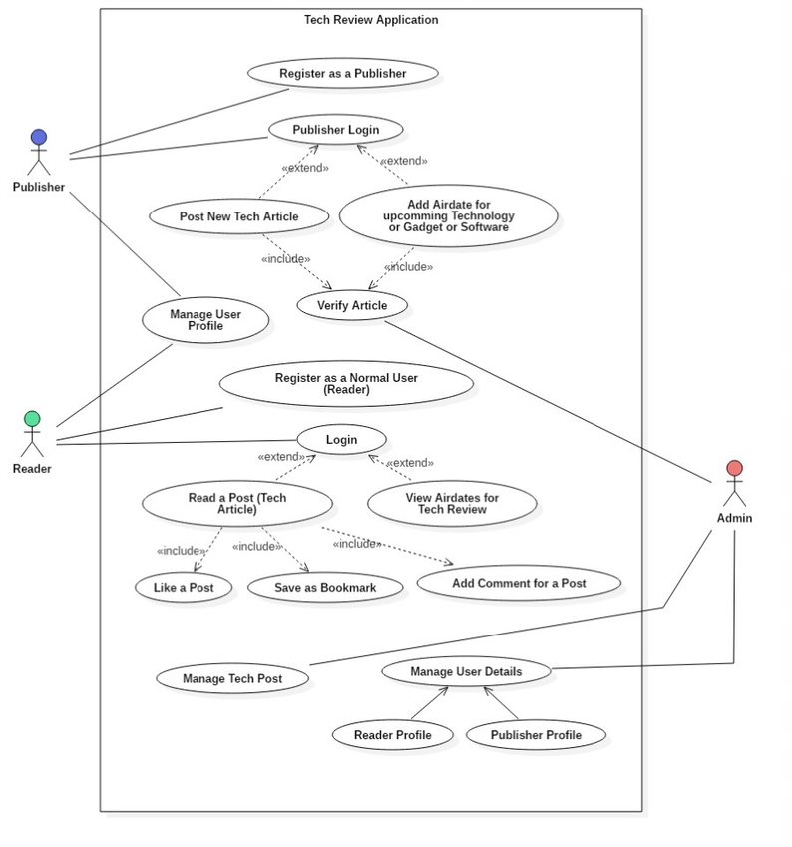

Sequence diagram

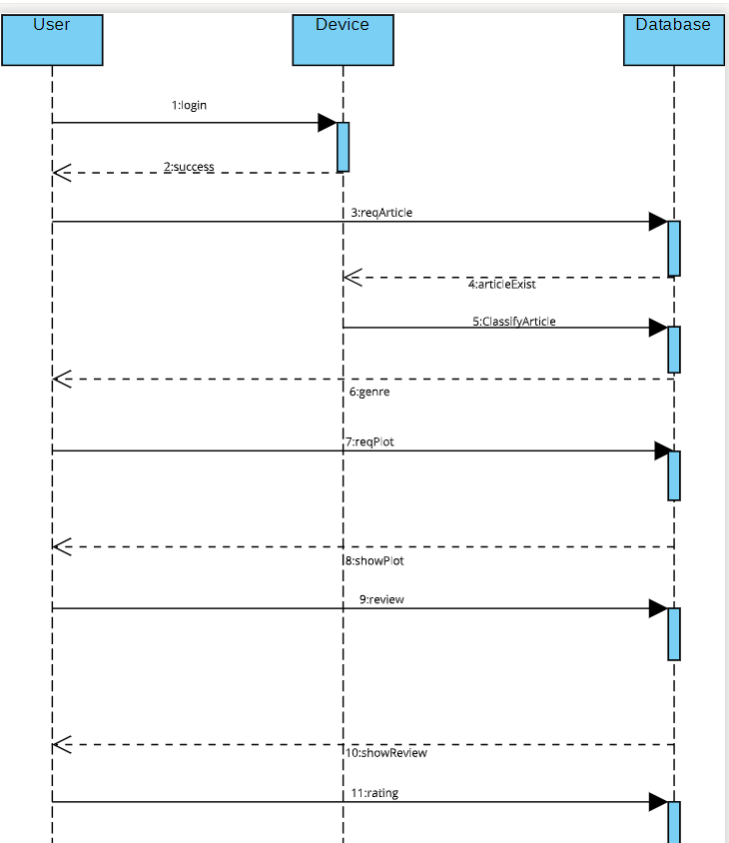

Proposed user Interface design
Welcome Page



About Us


Sign In

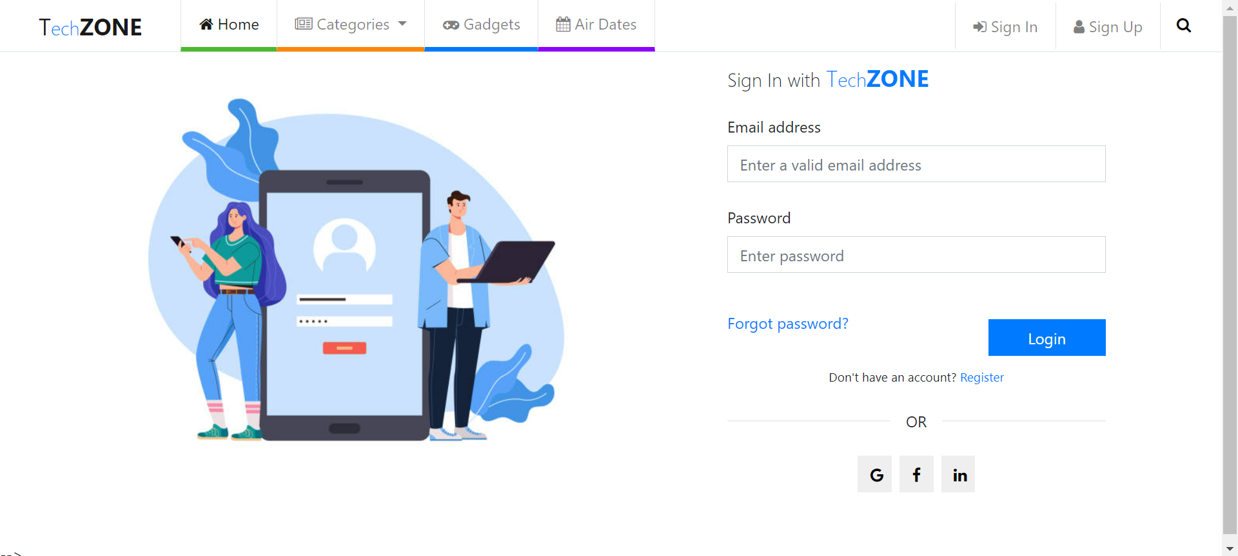

Sign Up

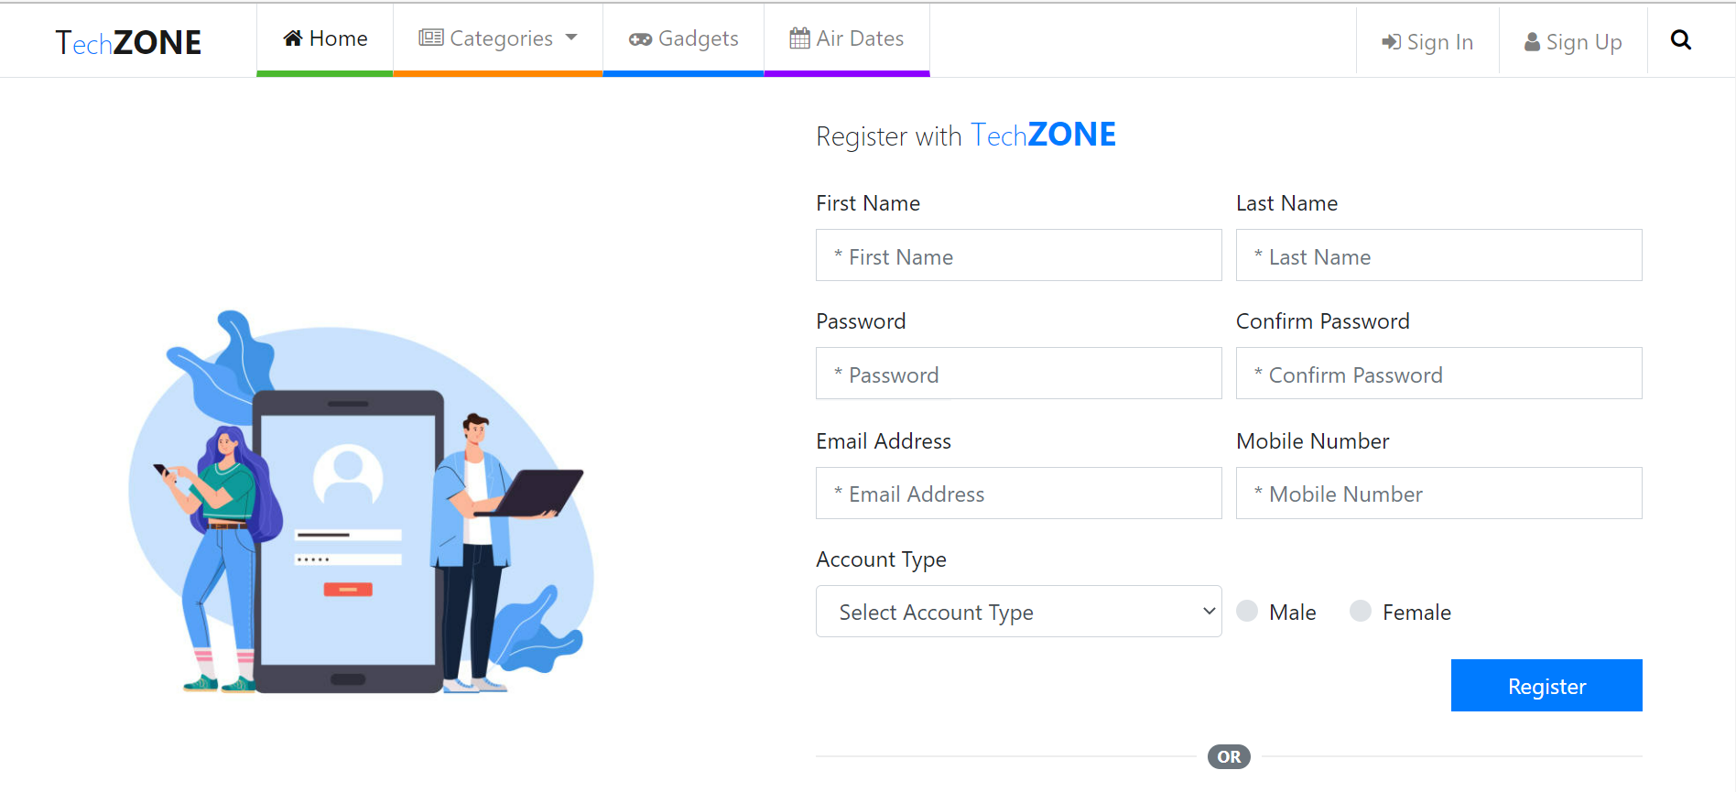

Air-Dates Calendar

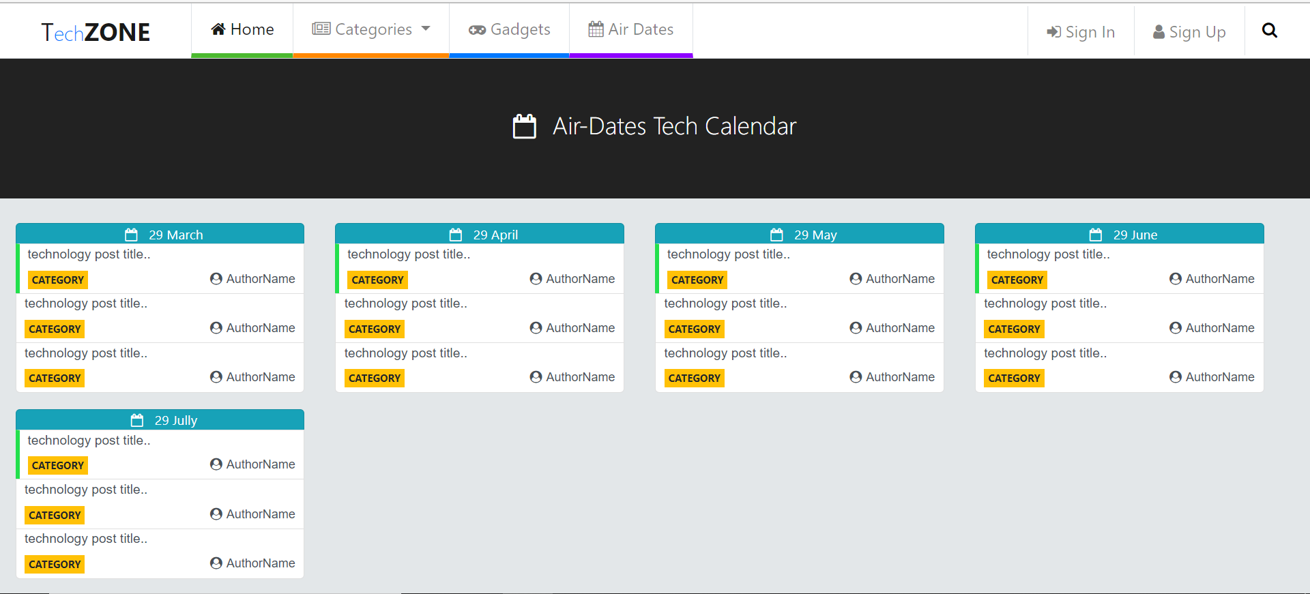

Home

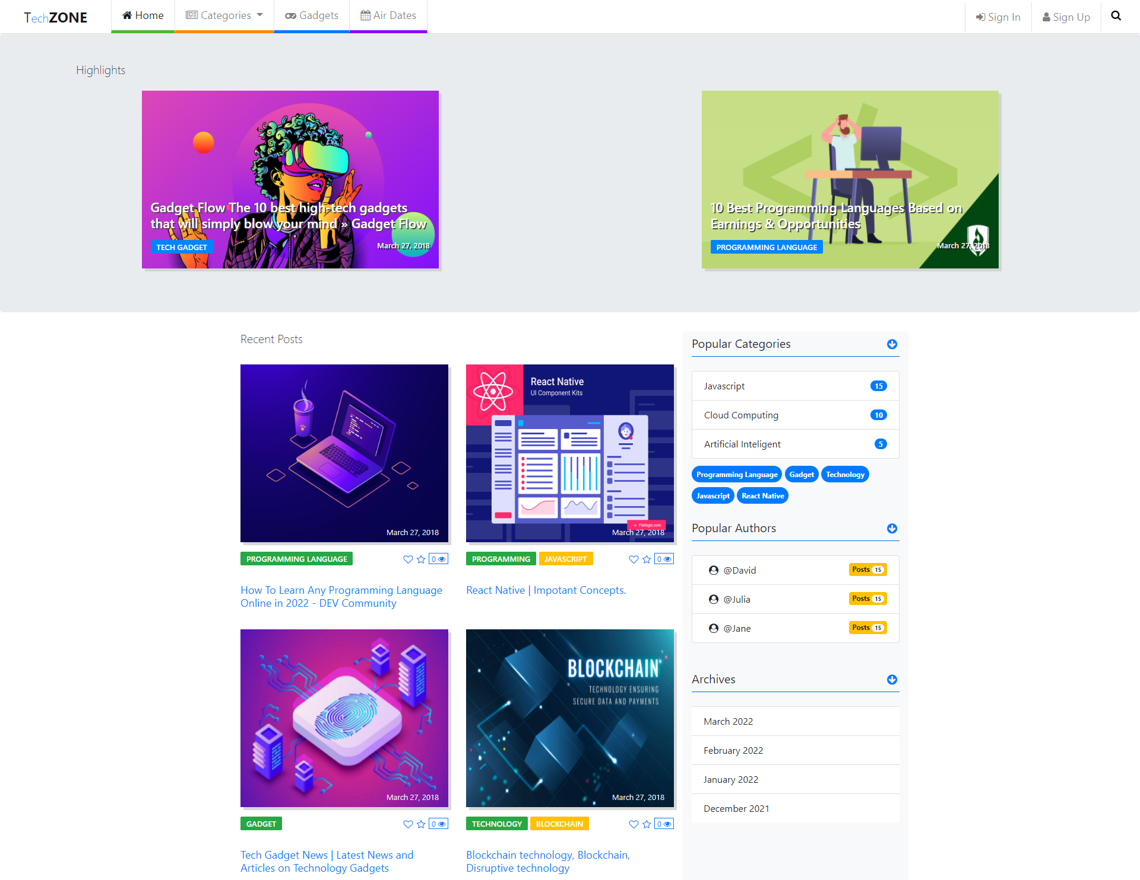

Database design changes
ER diagram

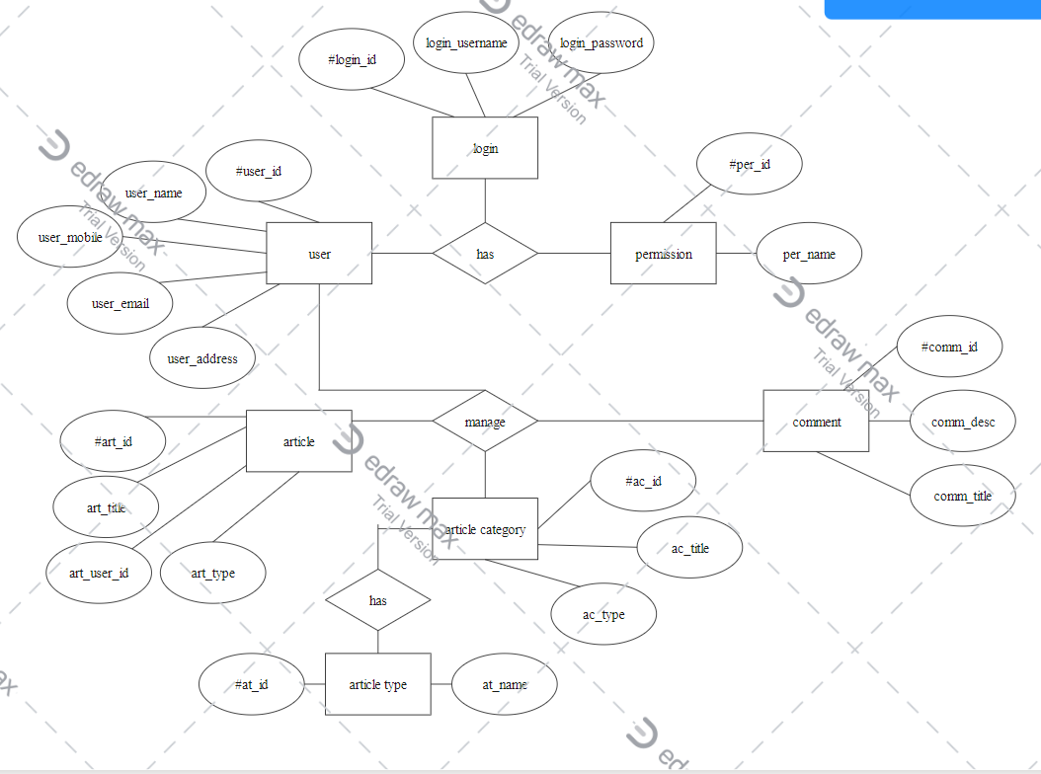

5 References
- https://www.w3schools.com/
- https://developer.mozilla.org/en-US/
- https://getbootstrap.com/
- EdrawMax software
- https://stackoverflow.com/

